Batch: B2 - H5 Roll No.: 16010121200
Experiment 01

Title: Data pre-processing using python on real world dataset

Objective:

To learn how to prepare the dataset

To learn various steps in Data –Preprocessing

Perform the Descriptive analytics (obtain measure of central tendency, dispersion, skewness, Kurtosis, and graphical representation of the given dataset)

Perform Exploratory Data Analysis over dataset

Course Outcome:

CO1: Understand basic concepts of data analytics to solve real-world problems

CO2: Experiment using advanced software techniques and tools to conduct thorough and insightful analysis

Books/ Journals/ Websites referred:
- Data Mining Concepts and Techniques Jiawei Han, Michelin Kamber, Jian Pie, 3rd edition

Resources used:
1. Kaggle datasets
2. Google Colaboratory
______________________________________________________________________

Theory (About Data Preprocessing):
Data preprocessing involves transforming raw data to well-formed data sets so that data mining analytics can be applied. Raw data is often incomplete and has inconsistent formatting. The adequacy or inadequacy of data preparation has a direct correlation with the success of any project that involve data analytics.
Preprocessing involves both data validation and data imputation. The goal of data validation is to assess whether the data in question is both complete and accurate. The goal of data imputation is to correct errors and input missing values – either manually or automatically through business process automation (BPA) programming.

Source of the dataset (URL):
https://www.kaggle.com/datasets/jessemostipak/hotel-booking-demand
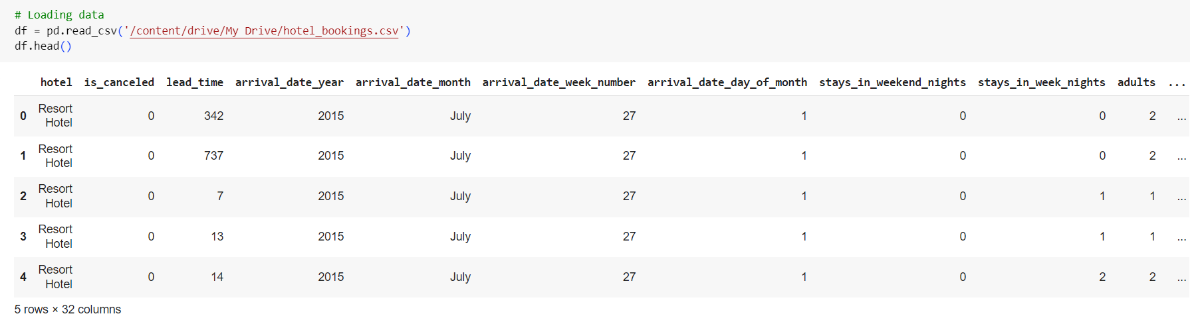

Data quality checklist:

Fill “Yes” if your chosen dataset satisfies the criteria and “No” otherwise. If your data does not satisfy two or more criteria even after preprocessing, then consider changing the dataset.
Quality Criteria | Before preprocessing | After preprocessing
Accuracy | Yes | Yes
Completeness | No | Yes
Consistency | No | Yes
Timeliness | Yes | Yes
Believability | No | Yes
Interpretability | No | Yes

Platform used by the student: Google Colaboratory (Python)

Following points should be written by students

Different steps in Data Preprocessing:

Finding missing, null values

Replacing missing, null values with statistical parameters

Encoding categorical data if needed (Write user defined function)

Normalization (Write user defined function)

Discretization (Write user defined function)

Working (Paste the code and Output for each Data Preprocessing task):

Data Preprocessing:

Finding missing/null values:

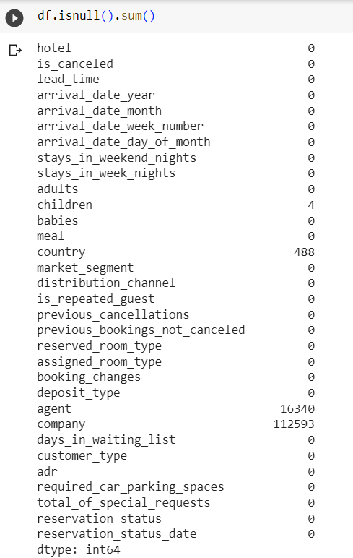

Replacing missing/null values with statistical parameters:

The ‘children’, ‘country’, ‘agent’ and ‘company’ columns contain missing/null values.

Dropping ‘agent’ and ‘company’ columns as they have too many missing values.

Replacing missing values in the ‘country’ column with the most frequent country.

Missing values in ‘children’ column are replaced with 0.

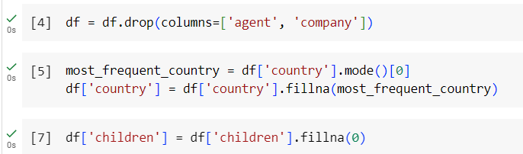

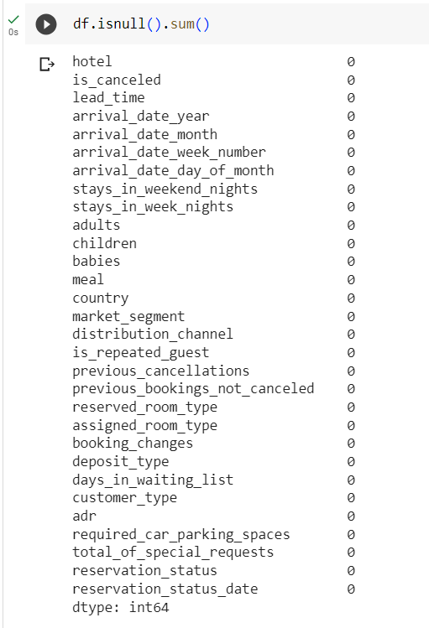

All missing/null values are dealt with.

Encoding categorical data:

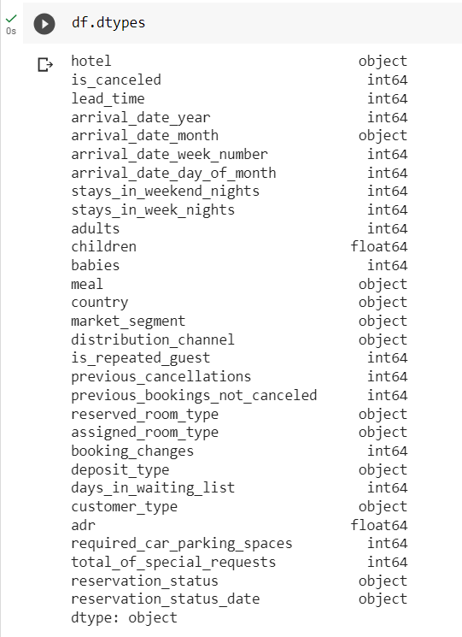

The ‘arrival_date_month’ is one of the columns containing categorical data.

Replacing month names by respective numbers 1-12.

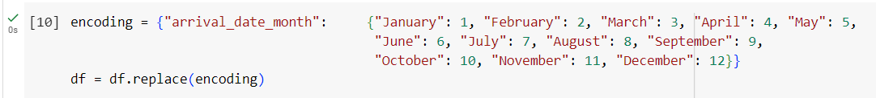

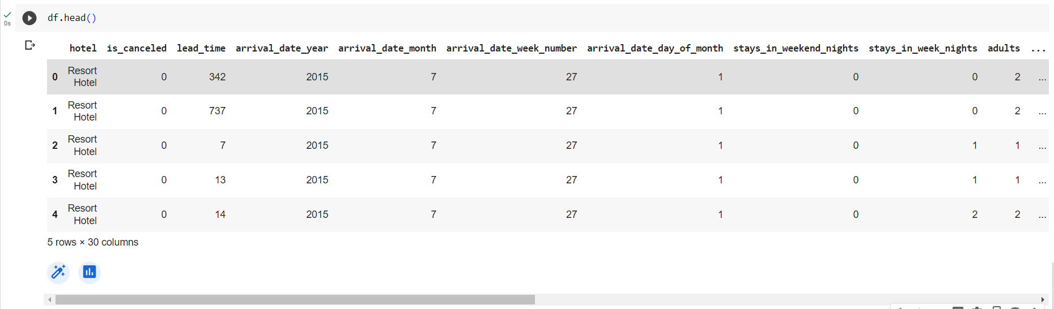

Removing incorrect data:

Removing any 0 values from adults column as bookings need to have at least one adult.

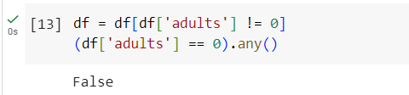

Discretization:

Making a seasons column and mapping arrival month to the season.

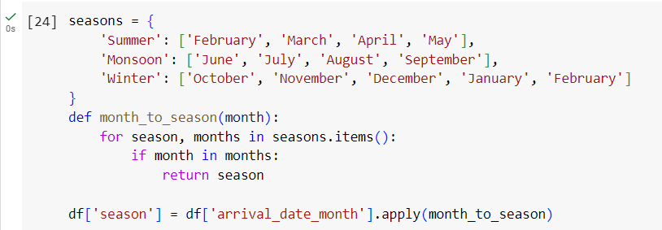

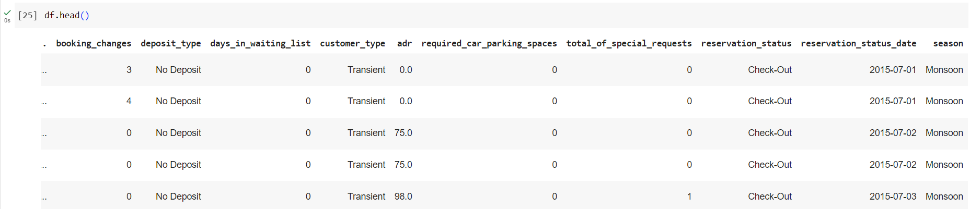

Removing outliers:

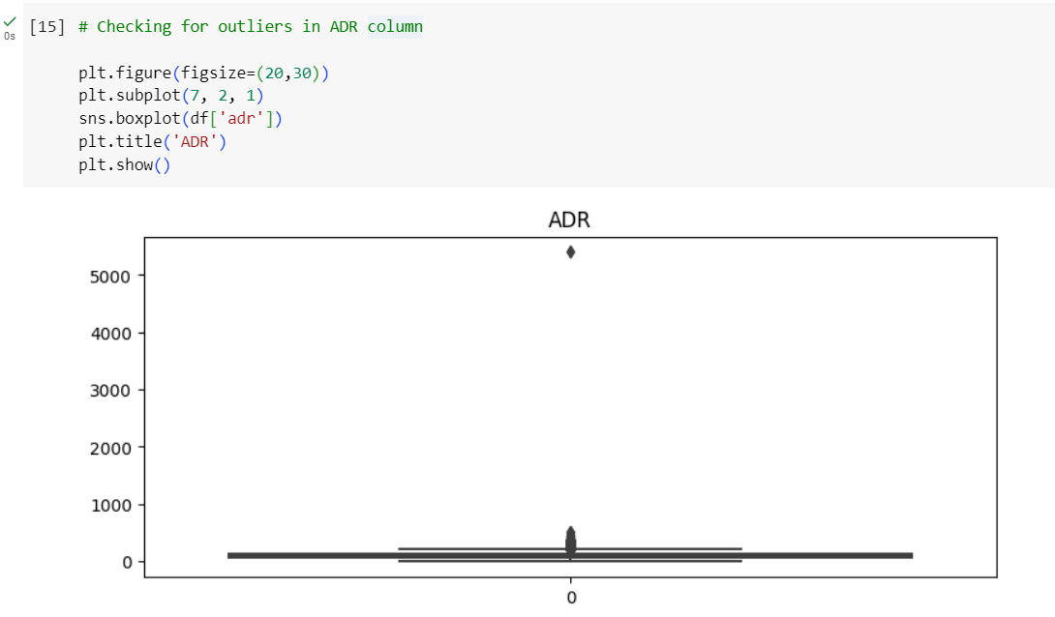

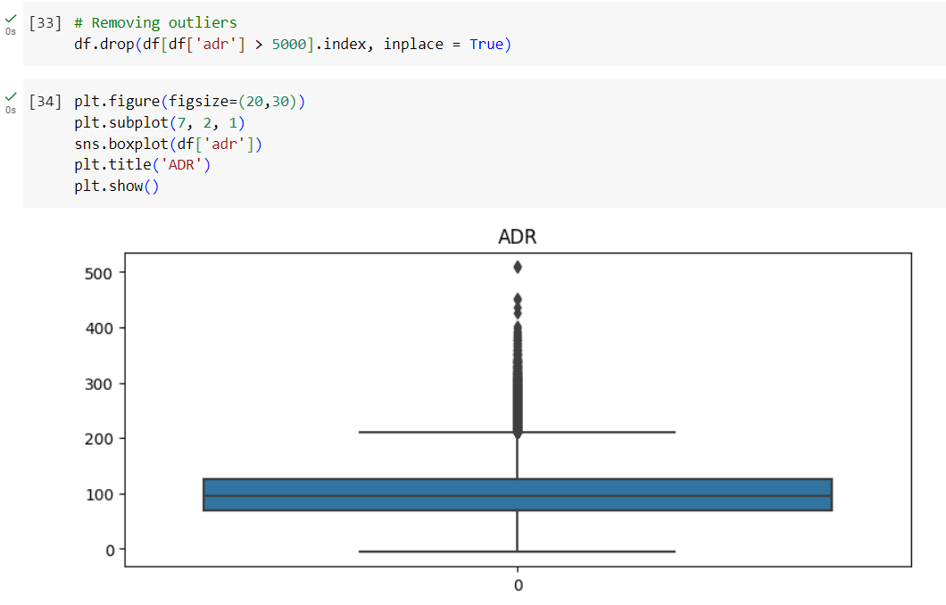

Descriptive Analysis:

Measures of central tendency and dispersion

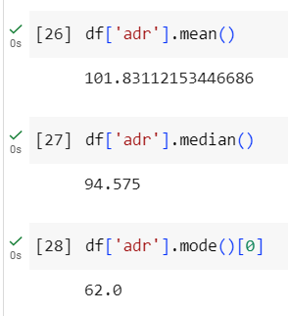

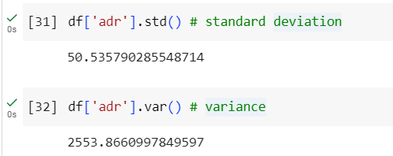

Skewness and Kurtosis

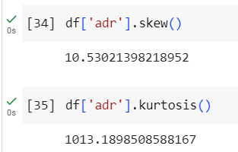

Graphical representation

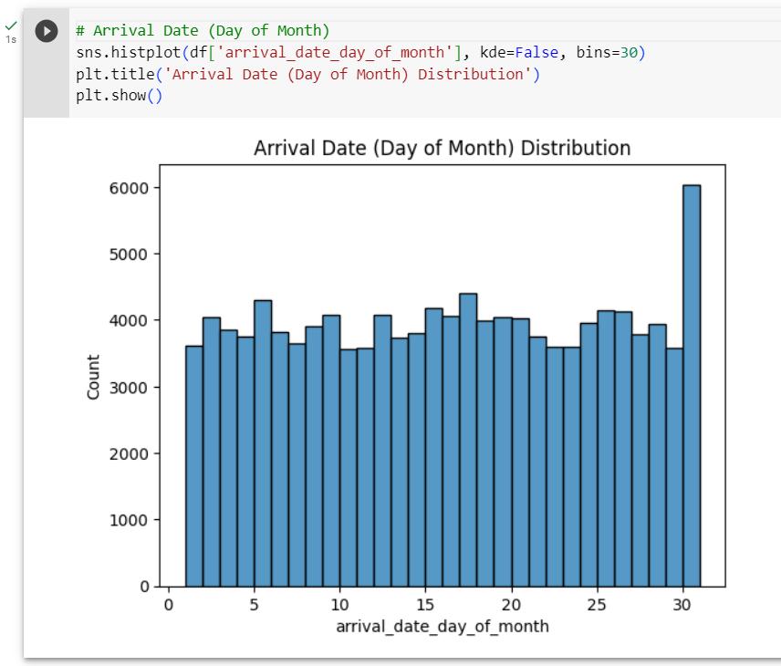

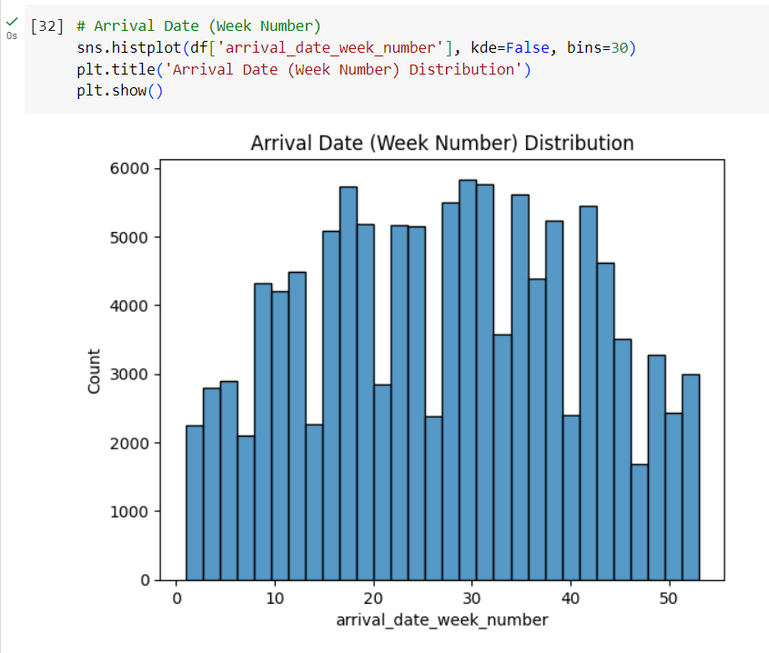

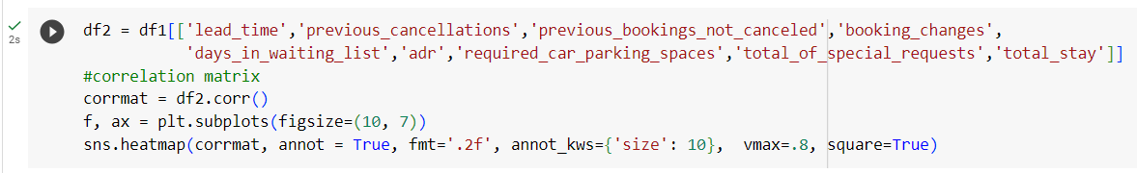

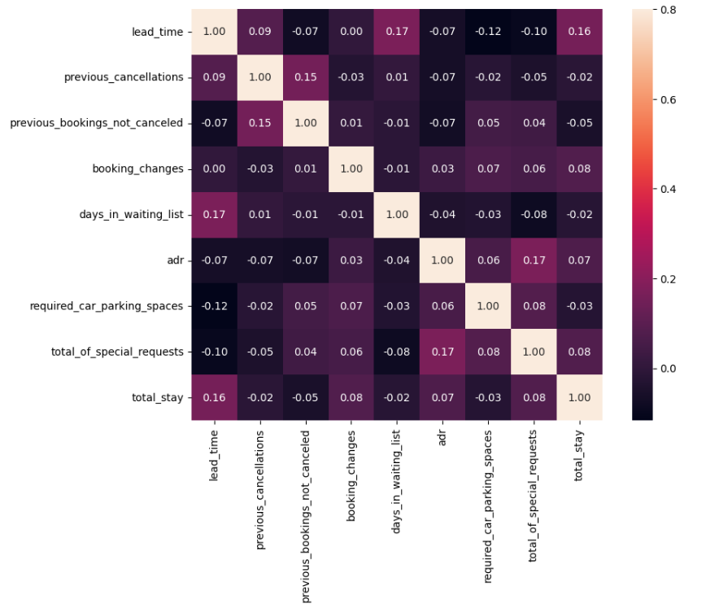
- Total stay length and lead time have slight correlation. This may means that for longer hotel stays people generally plan little before the the actual arrival.
- adr is slightly correlated with total_people, which makes sense as more no. of people means more revenue, therefore more adr.

EDA

Hotel-wise Comparison

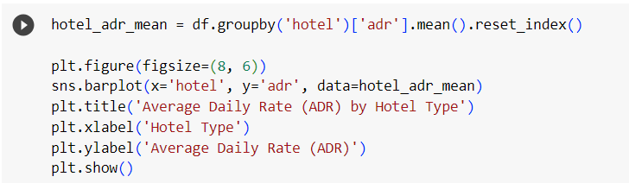

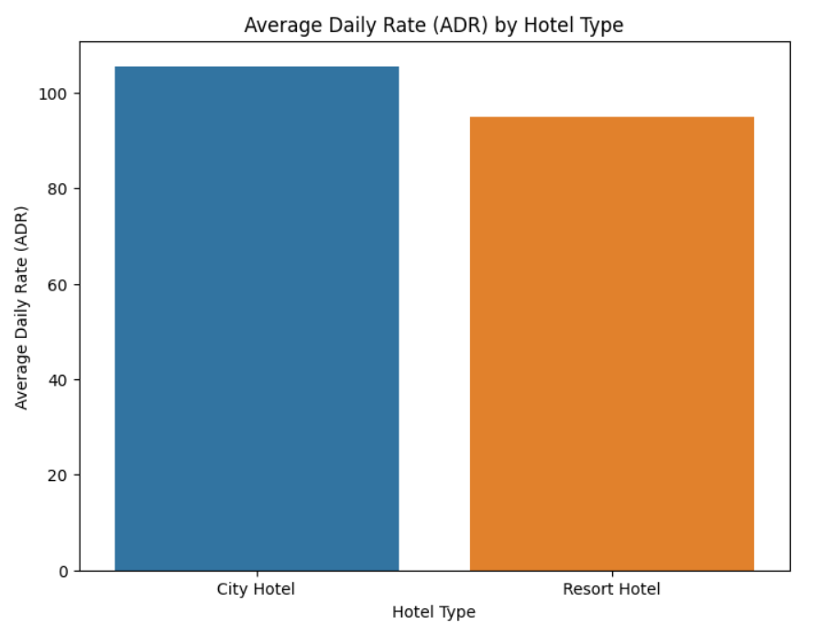

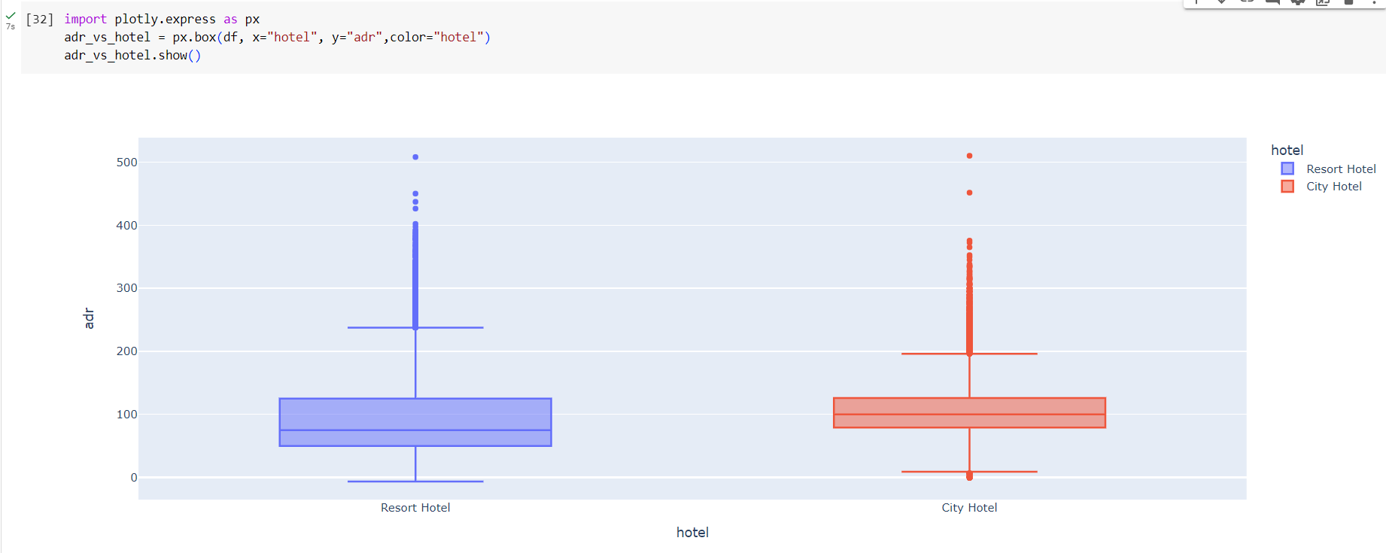

The range of ADR for both types of hotels varies, with City Hotel having a wider range.

City Hotel also has a higher maximum ADR compared to Resort Hotel.

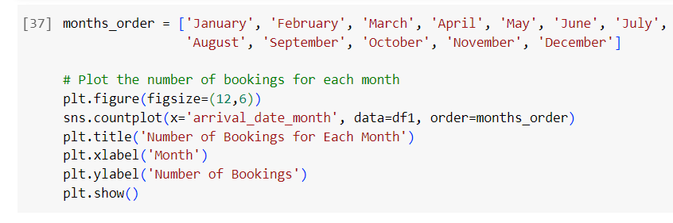

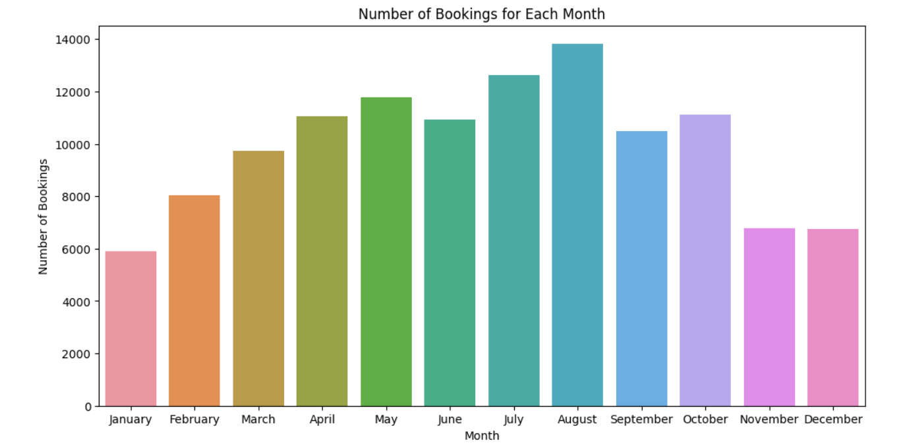

The number of bookings varies across the months, with August being the month with the most bookings and January being the month with the least bookings.

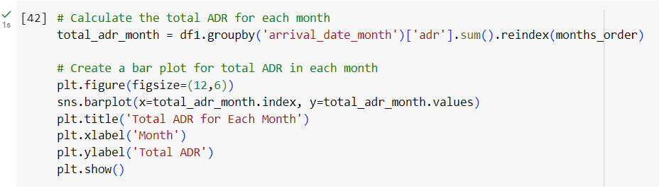

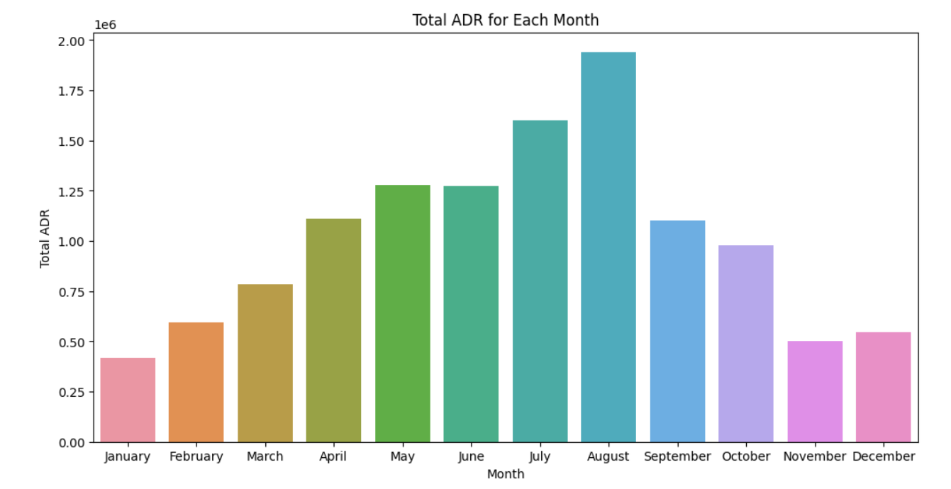

The total ADR is highest in August and lowest in January, which aligns with the number of bookings for each month.
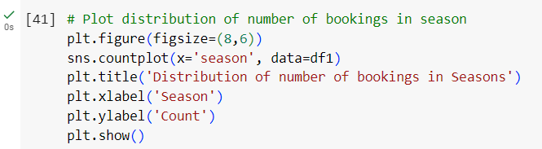
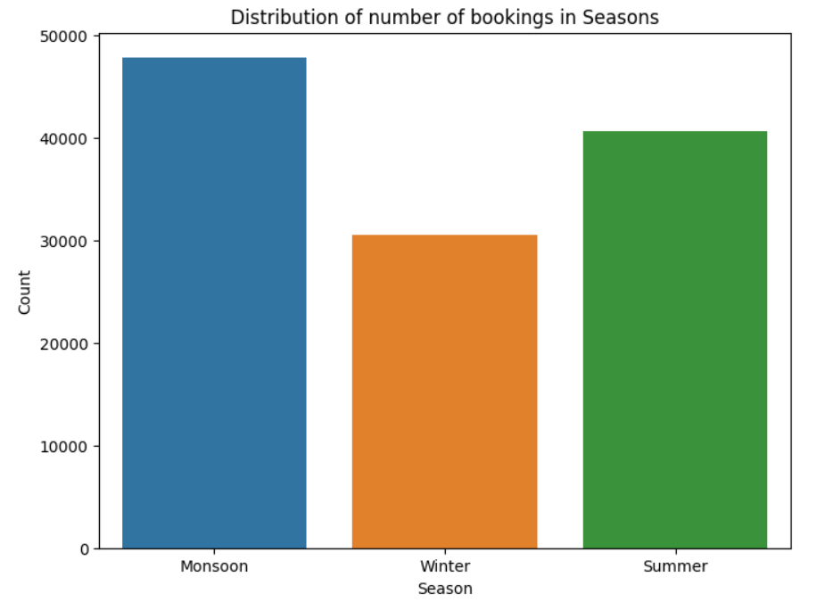

Most bookings are made in monsoon, followed by summer then winter.

Conclusion (Students should write in their own words):

Prepared the dataset and pre-processed it using python. Handled missing/null values, incorrect data, duplicate data, encoded categorical variables and removed outliers.

Performed descriptive analysis on the dataset and drew some conclusions using exploratory data analysis.

